**Quasar Setup:**

Install nodejs first:

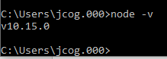

Node installation verified!!

Now install quasar: <http://quasar-framework.org>

Select Quasar CLI

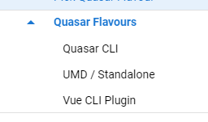

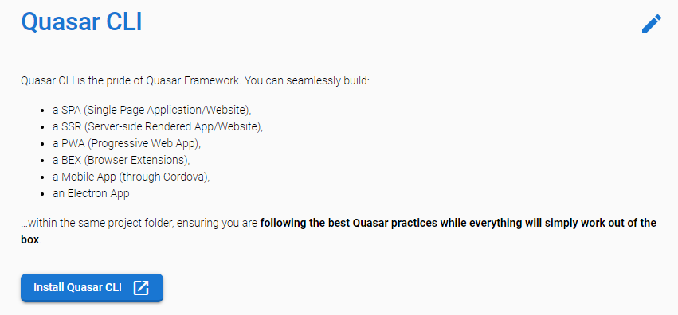

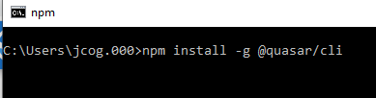

Installation complete:

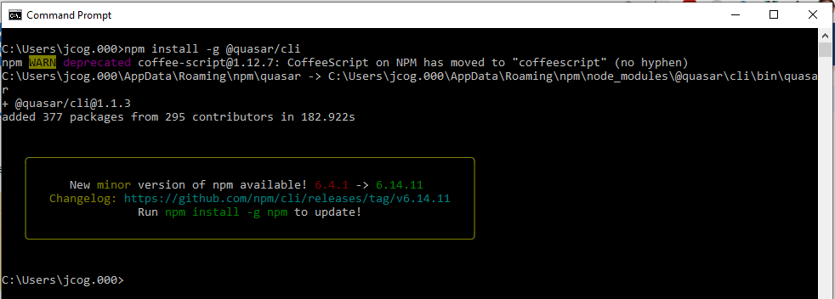

Create a First Project:

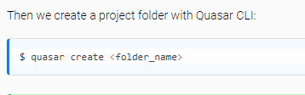

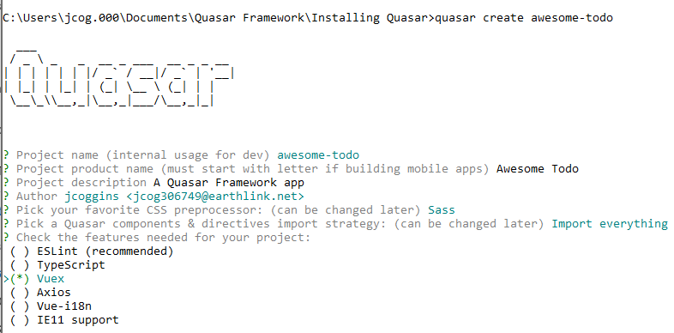

Press Enter

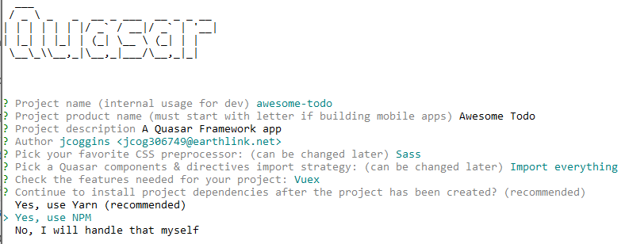

Press Enter and project is installed

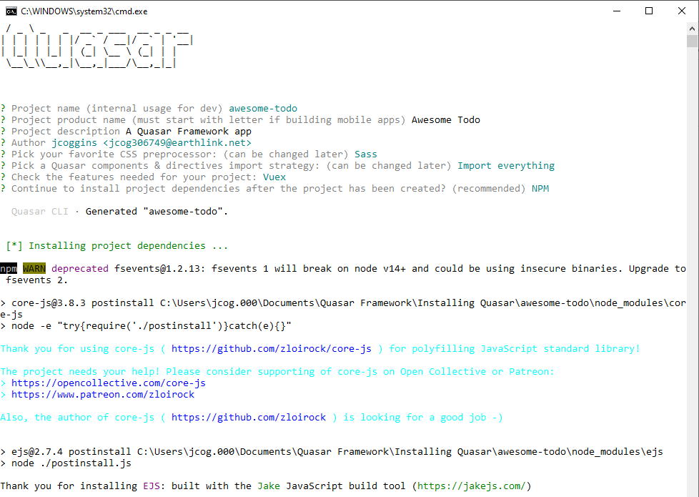

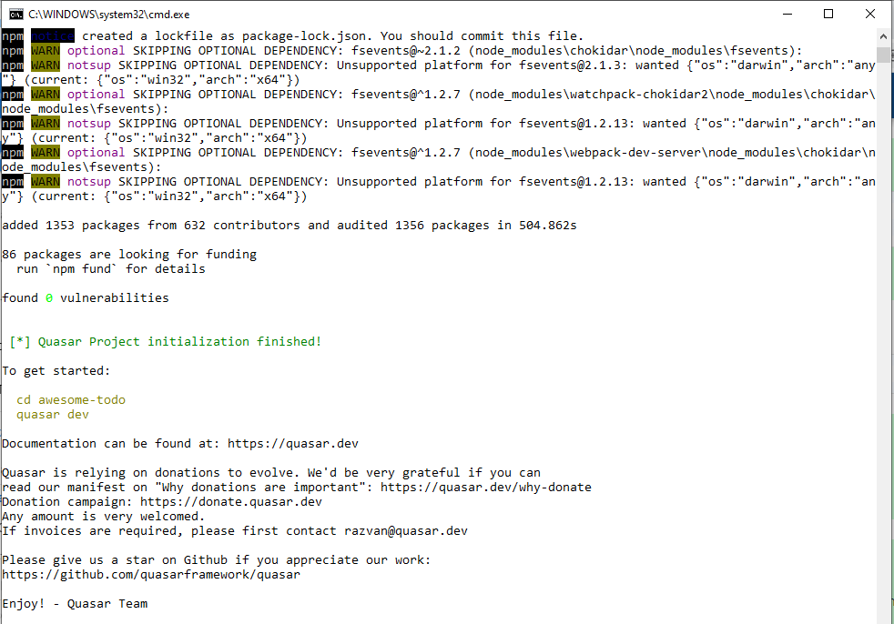

**At the prompt type: cd awesome-todo**

**then: quasar dev**

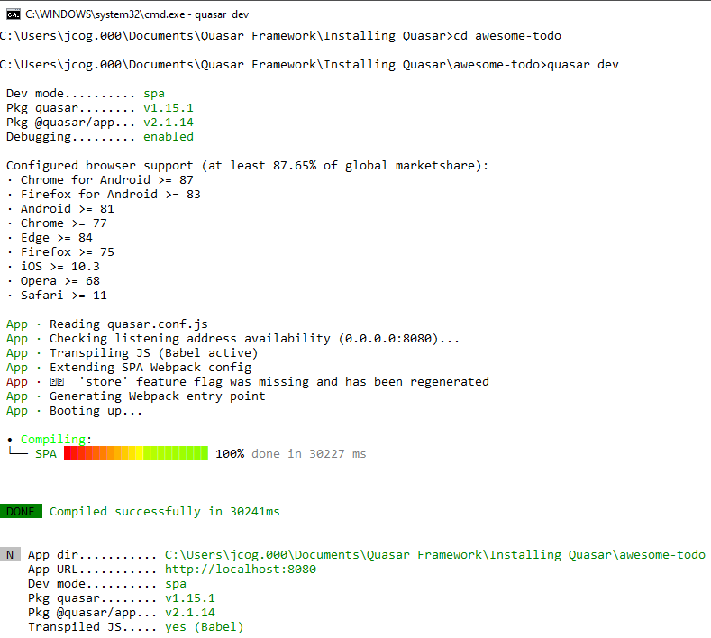

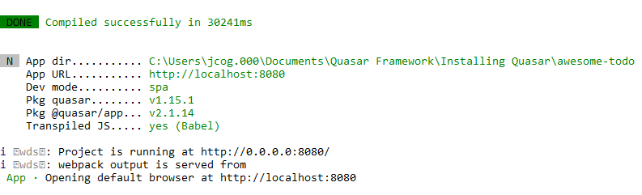

Quasar Browser appears:

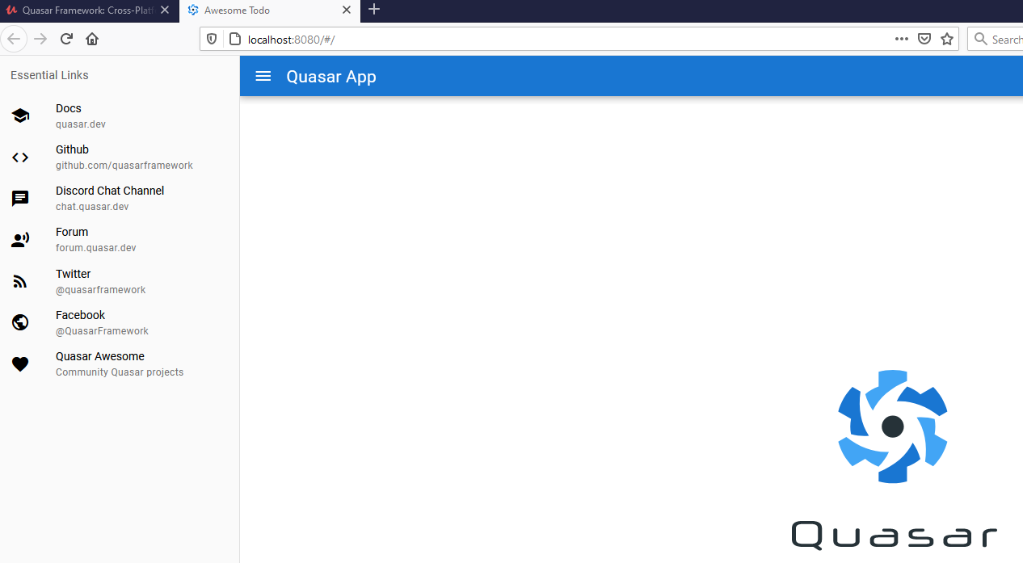

Folder structure of the awesome-todo project:

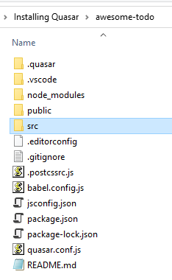

Main folder is the src folder:

Open that up:

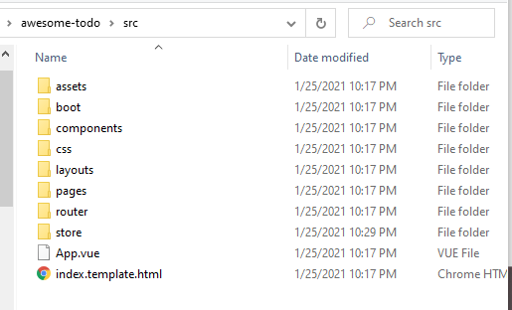

Then, select the App.vue file and open in Visual Studio Code:

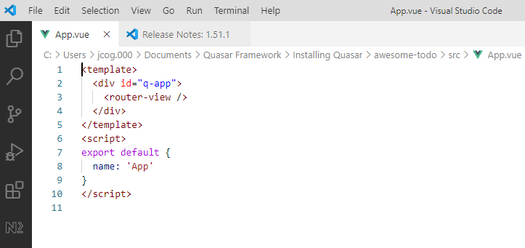

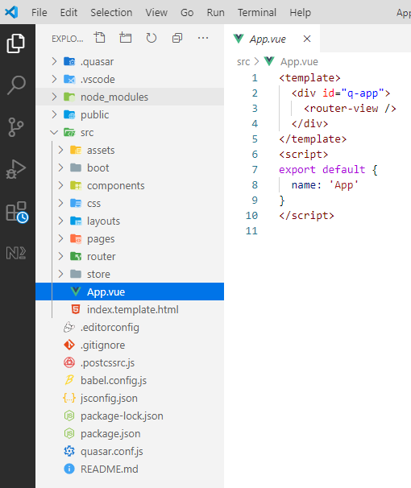

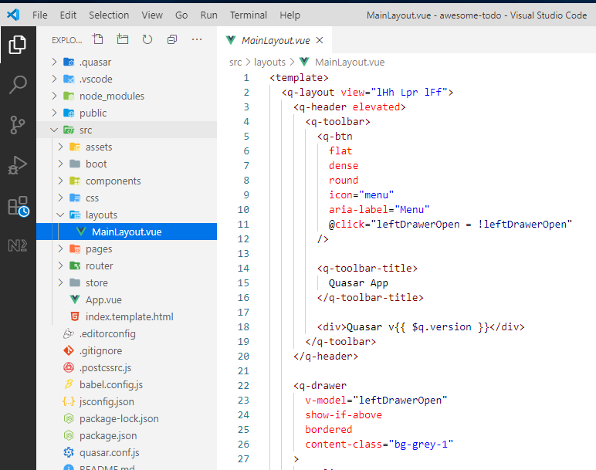

Purpose of different folders:

**Assets** – store images that can changed to base 64 by WebPack

App.vue – is the main vue component of your app

Layout of the app is loaded through the **router-view tag**

**Layouts –** Everything that surrounds the pages of your app.

e.g. Toobar at top, The Draw on the side

<q-page-container> contains the <router-view> which are urls to the pages

**Pages** – contains the index.vue file ( This is vue component for the one page we have )

and a default 404 Error page.

**Boot** – allows code to run before the app starts

**Component** – vue components location

**Css** – for quasar css components SCSS

**Router** – for all your routes Where URLs are assigned to vue components

**Statics** – images and fonts Images here are not compressed by WebPack

**Store** – used by Vuex